4ncl: Fischer’s catch
2018-19 season
Weekend 1
Fischer’s catch is now on its second season and during the summer months we’ve recruited a couple of players to strengthen the squad. We welcome Matt Staniforth, Kimberly Chong and a couple of Solihull players (Ray Carpenter and Paul Roper). Hopes for the season are high!
Round one
We were pitched against fellow Welsh team The Full Ponty on Saturday. Our experienced opponents out graded us on average, 1905 versus 1842. A tough opening round. The games were long and hard fought, and we sneaked a win 3.5-2.5. Star of the round was Ifan, for his well-controlled and convincing win. Matt’s game versus Mark Adams had a very interesting endgame and a surprise finish so worth checking out.
The Full Ponty  (Average rating 1905) |  | 2.5 – 3.5 | Fischer's Catch  (Average rating 1842)
Fletcher, John | 1997 | ½ - ½ | Smith, Olivia | 2132 e
Adams, Mark | 1965 | ½ - ½ | Staniforth, Matthew | 1958
Davies, Peter | 1976 | 0 - 1 | Rathbone-Jones, Ifan | 1907 e
Hughes, Anthony | 1903 | 1 - 0 | Chong, Kimberly | 1738
Quinn, Peter | 1838 u | 0 - 1 | Carpenter, Raymond | 1751
Dixon, Chris | 1755 | ½ - ½ | Fraser, Susanna | 1576

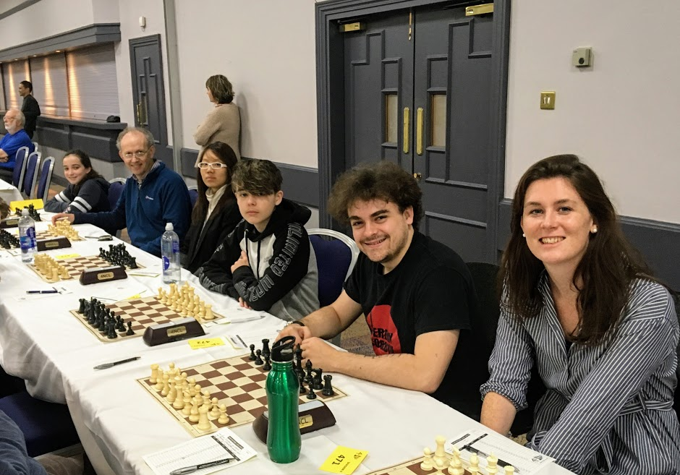
Round two
Round 2 versus Oxford 3
Sunday, we faced Oxford 3 and they on paper were stronger than ourselves. However, we beat the odds and took the victory 3.5 – 2.5. Star of the round was Matt for a tactic filled game and a lovely finish. A special mention to Susie for her fighting spirit and was extremely close to pulling off a great escape!
Fischer's Catch  (Average rating 1820) |  | 3.5 – 2.5 | Oxford 3  (Average rating 1917)
Smith, Olivia | 2132 e | 1 - 0 | Hadi, Justin | 2015
Staniforth, Matthew | 1958 | 1 - 0 | Burrows, Nick | 1937
Rathbone-Jones, Ifan | 1907 e | 1 - 0 | Terry, Sean | 1931
Chong, Kimberly | 1738 | 0 - 1 | Foster, Timothy | 1855
Roper, Paul | 1624 | ½ - ½ | Rudny, Tomasz | 1922 e
Fraser, Susanna | 1576 | 0 - 1 | Cole, Graham | 1842

An excellent opening weekend achieving the maximum four match points and a great team spirit. Some tough games ahead but roll on January!
Weekend Two: January 12-13th, Bedford
Round 3:
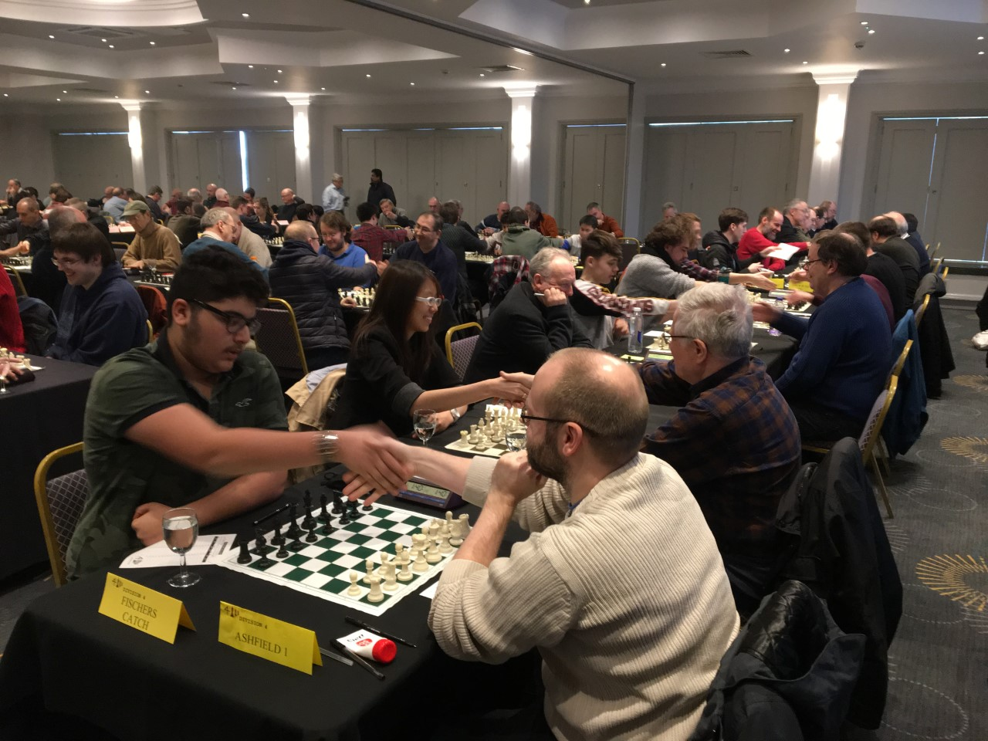
After a successful first weekend we had a tough draw against one of the top seeds (Ashfield 1) in the league. With an average board difference of over 200points we knew we faced a challenge.

Nevertheless, it was looking promising at time control with two comfortable draws from Ifan and Kimberly. Matt struggled to thrive in a Scandinavian and Ray played an ambitious sacrifice but sadly neither result went our way. Dan’s position looked very comfortable but after move 40 his opponent took advantage of Dan’s passive position and pressed for the win. The power of the bishop pair allowed me to pick up the win on top board.
Chong,Kimberly (1682) - Walker,Andrew N (1952)
4NCL Division 4 South Bedford, ENG, 12.01.2019

1.e4 e5 2.Nf3 Nc6 3.Bc4 Be7 4.0–0 Nf6 5.Re1 0–0 6.c3 d6 7.h3 Na5 8.Bf1 Be6 9.d4 exd4 10.cxd4 d5 11.e5 Ne4 12.Nfd2 Nxd2 13.Nxd2 c5 14.f4 f5 15.Nf3 c4 16.Ng5 Qd7 17.Qh5 h6 18.Nxe6 Qxe6 19.Be2 Nc6 20.Rd1 Bd8 21.Bxc4 Bb6 22.Kh1 Nxd4 23.Be3 dxc4 24.Bxd4 Rad8 25.Bxb6 Qxb6 26.Rxd8 Rxd8 27.Rd1 Rd3 28.Qe2 Qd4 29.Re1

½–½

Fischer's Catch  (Average rating 1802) |  | 2 - 4 | Ashfield 1  (Average rating 2033)
Smith, Olivia | 2132 e | 1 - 0 | Madden, Paul | 2170 e
Staniforth, Matthew | 1958 | 0 - 1 | Mercs, Peter J | 2080 e
Rathbone-Jones, Ifan | 1907 e | ½ - ½ | Garnett, John S | 1990 e
Carpenter, Raymond | 1751 | 0 - 1 | Combie, Alex B | 2020 e
Chong, Kimberly | 1682 | ½ - ½ | Walker, Andrew N | 1952 e
Jaberansari, Daniel | 1382 | 0 - 1 | Naylor, Michael A | 1990 e
The evening was spent analysing the games during a team meal and playing blitz with fellow welsh teams.
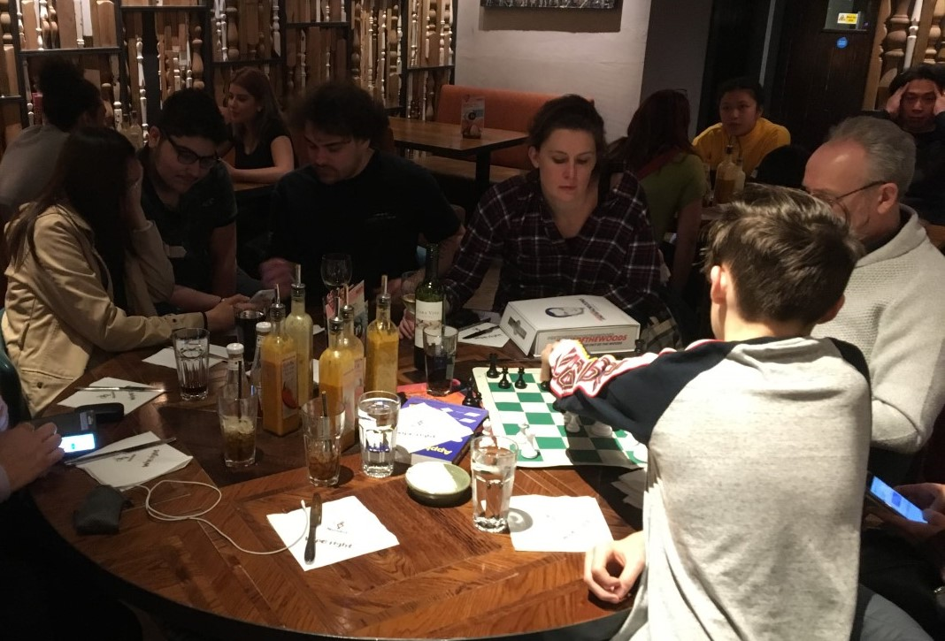

Round 4:
Sunday was a big struggle against another strong team (Check Innmates 2). I was on the worse side of a Scandinavian, manage to equalise and press in the middle to endgame but a draw was agreed. Matt had a wild game but sadly missed a tactic involving a queen sacrifice. Another solid performance from Ifan on board three, securing a draw and still remains unbeaten for the season. Ray was pressing with both kings castling queenside, however he came unstuck with his opponent’s passed h pawn. Kimberly’s opponent played an interesting opening with f4 quickly followed by b4. After multiple pieces exchanged, there was a lack of co-ordination in Kimberly’s position and this led to a drop in material with her opponent pushing a dangerous passed outside pawn.
The performance of the day came from Dan who quickly mounted a dangerous kingside attack. He came so close to a beautiful win and even his opponent praised his performance after the game. A tactic missed at the end under time pressure and disaster the point was claimed by the opposition.
Check Innmates 2  (Average rating 1967) |  | 5 – 1 | Fischer's Catch  (Average rating 1802)
Tucker, David S | 1989 | ½ - ½ | Smith, Olivia | 2132 e
Girdlestone, Paul C | 2001 | 1 - 0 | Staniforth, Matthew | 1958
Rabbitt, Michael | 2004 | ½ - ½ | Rathbone-Jones, Ifan | 1907 e
Tomboline, David | 1941 | 1 - 0 | Carpenter, Raymond | 1751
Parker, Francis | 1962 | 1 - 0 | Chong, Kimberly | 1682
Bourne, Johnathan D | 1905 | 1 - 0 | Jaberansari, Daniel | 1382
Player of the weekend: Dan
Weekend Three: February 9-10th, Daventry
Round 5:
We were pitched against Ashfield 2 on Saturday and we were all keen to get revenge from losing to their first team in round 3. However, disaster struck prior to the round with Ifan’s car breaking down enroute and him racing to make the default time. A couple of minutes too late Ifan’s board was defaulted and so we were already at -2 in the match position (-1 penalty point due to the default). Ifan and his opponent managed to play a friendly game, where Ifan came out on top.
I played an upcoming junior and managed to take advantage of a few suspicious knight manoeuvres which allowed me to gain space and press on the kingside. Matt won material early on and managed to maintain his advantage and cruised to victory. Kimberly faced the Blackmar Diemer gambit and some successful prep had a comfortable position and looked to be pressing. Pieces were exchanged and position equalised, and a draw was agreed.
Paul picked up two pawns in the middlegame and then managed to exchange queens. The rest was just technique to convert the rook endgame into a win. The game of the day goes to Susie with some beautiful tactic play. From the opening her opponent dropped two minor pieces in exchange for some compensation (5 pawns!).
Taylor ,R - Fraser ,S
4NCL , 09.02.2019

1.d4 d5 2.Nf3 Nf6 3.Bg5 Ne4 4.Bf4 c5 5.e3 Nc6 6.c3 Qb6 7.Qb3 c4 8.Qxb6 axb6 9.Na3 e5 10.Nb5 Ra5 11.Nc7+ Kd8 12.Nxe5 Nxe5 13.dxe5 g5 14.Nxd5 Rxd5 15.Bxc4 Rc5 16.Bxf7 gxf4 17.exf4 Rc7 18.Bh5 Rg8 19.Bf3 Nc5 20.Rd1+ Rd7 21.Bd5 Rgg7 22.f5 Kc7 23.f4 Rd8 24.f6 Rgd7 25.c4 Ne6 26.g3 b5 27.b3 bxc4 28.bxc4 b5 29.Ke2 bxc4 30.Bxc4 Rxd1 31.Rxd1

Black to play and win..

XABCDEFGHY
8-+ltr-vl-+(
7+-mk-+-+p'
6-+-+nzP-+&
5+-+-zP-+-%
4-+L+-zP-+$
3+-+-+-zP-#
2P+-+K+-zP"
1+-+R+-+-!
xabcdefghy
Nxf4+! 32.gxf4 Bg4+

0–1

A great team effort and special thanks to Nerys (Ifan’s mother) for coping marvellously under stress and safely arriving at the venue. Spirits were high and celebrations continued at a jolly team meal, followed by some blitz!

Fischer's Catch  (Average rating 1821) |  | 3½ - 1½ | Ashfield 2  (Average rating 1874)
Smith, Olivia | 2110 e | 1 - 0 | Gogia, Armaan | 1982 e
Staniforth, Matthew | 1943 | 1 - 0 | Levens, David G | 1940
Rathbone-Jones, Ifan | 1952 e | d - 1 | Flynn, David | 1930 e
Chong, Kimberly | 1720 | ½ - ½ | Graham, Neil | 1825 e
Roper, Paul | 1623 | 1 - 0 | Hill, Maurice J | 1810 e
Fraser, Susanna | 1578 | 1 - 0 | Taylor, Robert P | 1757 e

Round 6:
Another close draw on Sunday with our opponents only slightly out grading us on paper by less than 20 points per board. Susie our star from yesterday won some material early on and seemed to have the position in control. Her rooks became discoordinated and allowed her opponent’s attack to succeed. Ray had a beautiful positioned knight on d3 and pressure quickly mounted, winning material and securing the point. A tactic for Kimberly picked up a pawn and then this lead to further problems for her opponent with the dark square weaknesses. A lack of king safety dropped more material and her opponent’s bishop pair were no match for Kimberly’s dominating rook and bishop combination.
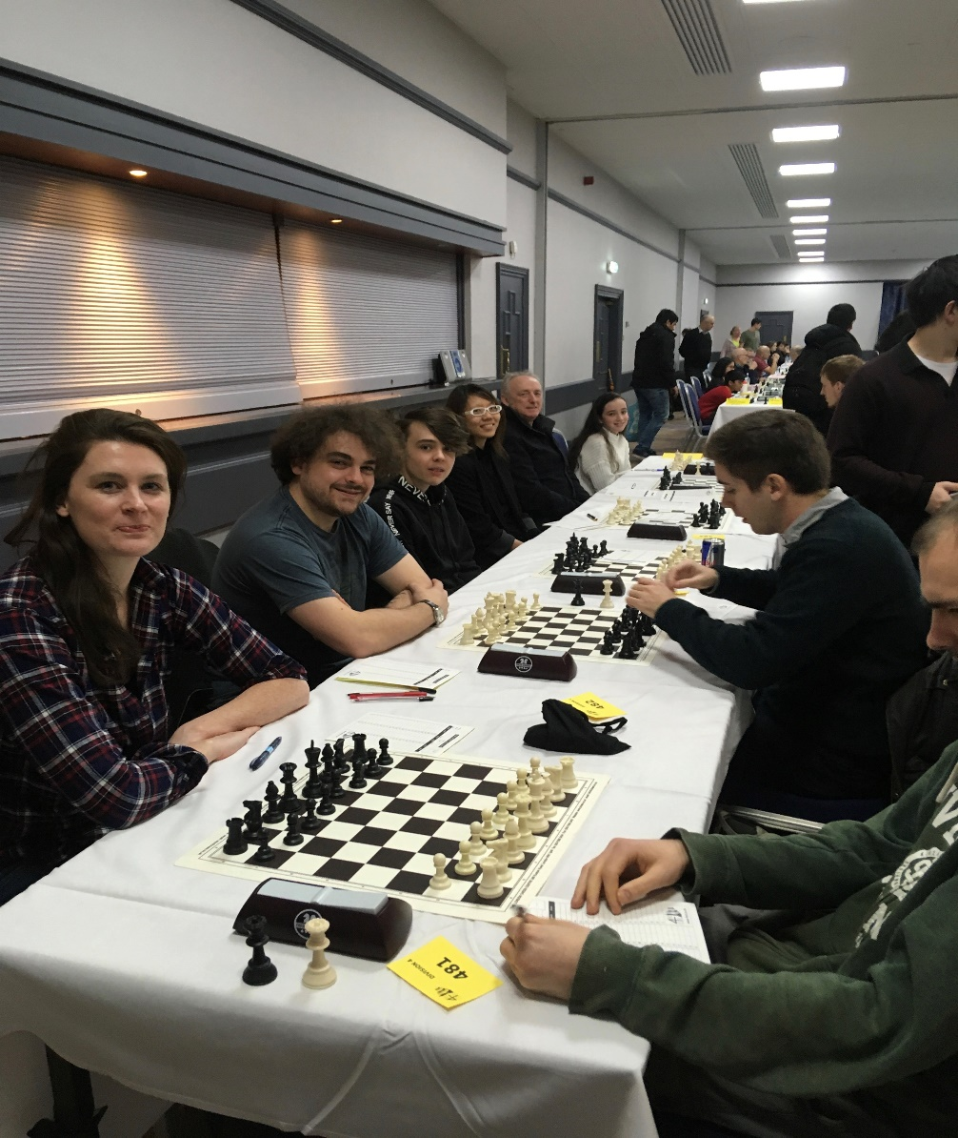
Ifan’s opponent seemed to get the better out of the opponent and had a dangerous f pawn. A miss in calculation and Ifan picked up material and the danger seemed to pass. It resulted in Ifan having a passed e pawn in a queen and pawn endgame. The question was whether Ifan could avoid all the checks. The king matched around the board picking up more material and Ifan secures another victory. Matt looked comfortable out of the opening, but his opponent worked the queen and knight combination a treat and put Matt under pressure in the middlegame. This resulted in material down in a bishop v knight endgame which Matt was unable to hold.

After a mammoth 7 hour game and 137 moves a draw was agreed in my game. A miscalculation in middle game result in material loss with little compensation for myself. The rook endgame was difficult to convert and due to the match position, my opponent wished to play on.
All Anands on Deck  (Average rating 1857) |  | 2½ - 3½ | Fischer's Catch  (Average rating 1839)
Wilks, Simon | 2147 e | ½ - ½ | Smith, Olivia | 2110 e
Penna, Tommaso | 2004 | 1 - 0 | Staniforth, Matthew | 1943
Jones, Tibor | 1878 | 0 - 1 | Rathbone-Jones, Ifan | 1952 e
Stamatopoulos, Apostolos | 1800 | 0 - 1 | Chong, Kimberly | 1720
Samadov, Samir | 1769 | 0 - 1 | Carpenter, Raymond | 1733
Mize, Dylan | 1545 | 1 - 0 | Fraser, Susanna | 1578

Player of the weekend: Kimberly
With six rounds down we are currently in 7th position with 8 points (four wins and two loses). The current target is to score more points than the previous season (10 points), this may be achievable with a weekend to spare. We are currently looking to recruit new players to the team and would show a preference to both juniors and women. Please contact via email oliviasmith87@hotmail.com to express an interest.

